Agentic Resume System

Milestone II: Multi-Agent Workflow

1. Architecture Diagram
The following diagram illustrates the multi-agent workflow:
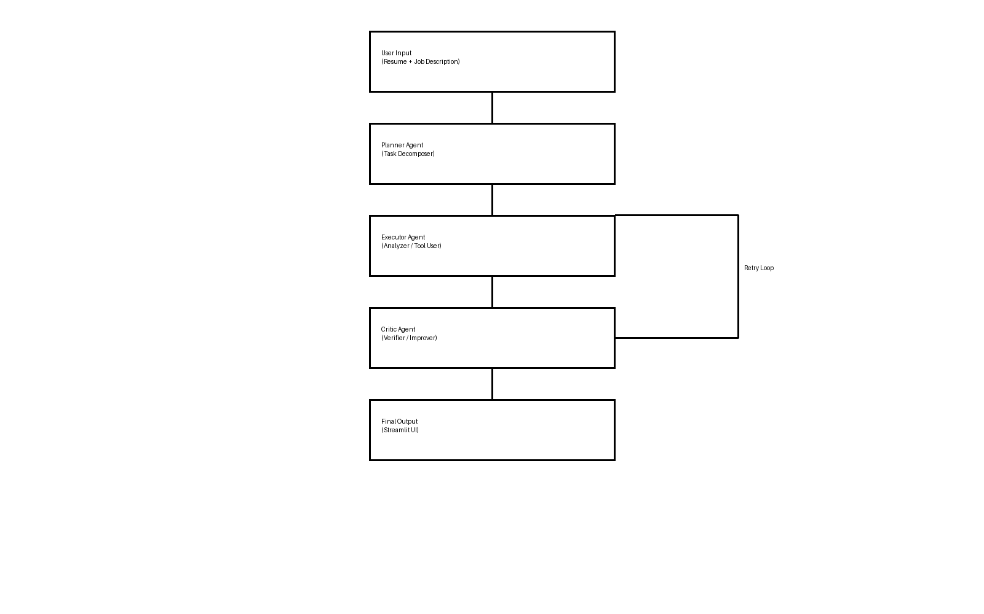

2. System Overview
The Agentic Resume System (Milestone II) extends the initial UI by introducing a multi-agent workflow. Instead of generating responses directly, the system uses three specialized agents that collaborate to analyze resumes and job descriptions, improving output quality through structured reasoning and validation.

3. Agent Roles and Responsibilities
Planner Agent (Task Decomposer)
Role: Breaks the problem into structured tasks
Input: Resume text, Job description
Output: Task list such as extracting skills and comparing requirements
Executor Agent (Analyzer / Tool User)
Role: Performs resume-job matching
Input: Tasks, Resume, Job description
Output: Resume recommendations
Critic Agent (Verifier / Improver)
Role: Evaluates and improves output quality
Input: Executor output, Job description
Output: Refined output or approval

4. Communication Flow
Pipeline: Planner → Executor → Critic → Output
If output is weak, the Critic sends it back to the Executor (max 2 retries).

5. Failure Handling
Missing input: UI displays warning
Weak output: Critic requests refinement
Infinite loop prevention: Retry limit (2 retries)
Empty output: Default suggestions used

6. Multi-Agent Implementation Code
import streamlit as st

st.title('AI Agentic Resume System - Multi-Agent Version')

# -----------------------------
# PLANNER AGENT
# -----------------------------
def planner_agent(resume_text, job_desc):
return {
"tasks": [
"Extract resume skills",
"Extract job requirements",
"Compare skills",
"Generate recommendations"
]
}

# -----------------------------
# EXECUTOR AGENT
# -----------------------------
def executor_agent(plan, resume_text, job_desc):
recommendations = []

if "Python" in job_desc and "Python" not in resume_text:
recommendations.append("Add Python experience")

if "SQL" in job_desc and "SQL" not in resume_text:
recommendations.append("Add SQL projects")

recommendations.append("Highlight relevant experience")

return "\n".join(f"- {r}" for r in recommendations)

# -----------------------------
# CRITIC AGENT
# -----------------------------
def critic_agent(output):
feedback = []

if len(output) < 50:
feedback.append("Add more detail")

if "projects" not in output.lower():
feedback.append("Include project-based suggestions")

if feedback:
improved = output + "\n- Add quantified achievements\n- Tailor keywords better"
return improved, False

return output, True

# -----------------------------
# CONTROLLER PIPELINE
# -----------------------------
def multi_agent_pipeline(resume_text, job_desc):
plan = planner_agent(resume_text, job_desc)

for _ in range(2): # retry loop
output = executor_agent(plan, resume_text, job_desc)
reviewed_output, approved = critic_agent(output)

if approved:
return reviewed_output

output = reviewed_output

return output

# -----------------------------
# STREAMLIT UI (UPDATED)
# -----------------------------
resume_file = st.file_uploader('Upload your Resume (PDF or DOCX)')
job_desc = st.text_area('Paste Job Description Here', height=150)

if st.button('Generate Resume Recommendations'):
if resume_file and job_desc:
# Read resume file
resume_text = resume_file.read().decode(errors="ignore")

# Run multi-agent system
final_output = multi_agent_pipeline(resume_text, job_desc)

# Display results
st.subheader('Multi-Agent Resume Recommendations')
st.text_area('Results', value=final_output, height=250)

else:
st.warning('Please upload a resume and paste a job description.')

